Van Noort, Adrian Colin (Jan) (based mainly on CALM News 1985)
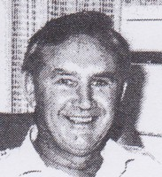
Graduated from Australian Forestry School in 1951. Worked for Forests Department at Walpole. Soil surveyor in 1950s. Involved in jarrah silviculture research at Dwellingup in late 1950s. OIC of pine plantations in Wanneroo in the early1960s. Pine Plantation superintendent 1966. Promoted to Chief of Division in 1980/81. Introduced the Plantation Operations Control System (POCS), after visiting New Zealand pine forests in 1970. Manager Silviculture Branch 1985. Retired 1985.

